**How to Review a New Case**

A full review is required on every new case before reaching out to a client, whether it is a welcome call or a transfer case. The goal is for the transition from Sales to Servicing or from one Tax Analyst to another to be as seamless as possible. If anything doesn’t seem to make sense or you have any questions work with your team and manager to find the answers before you reach out to the client.

**Reviewing Dice & the I-drive**

* Deal Tab

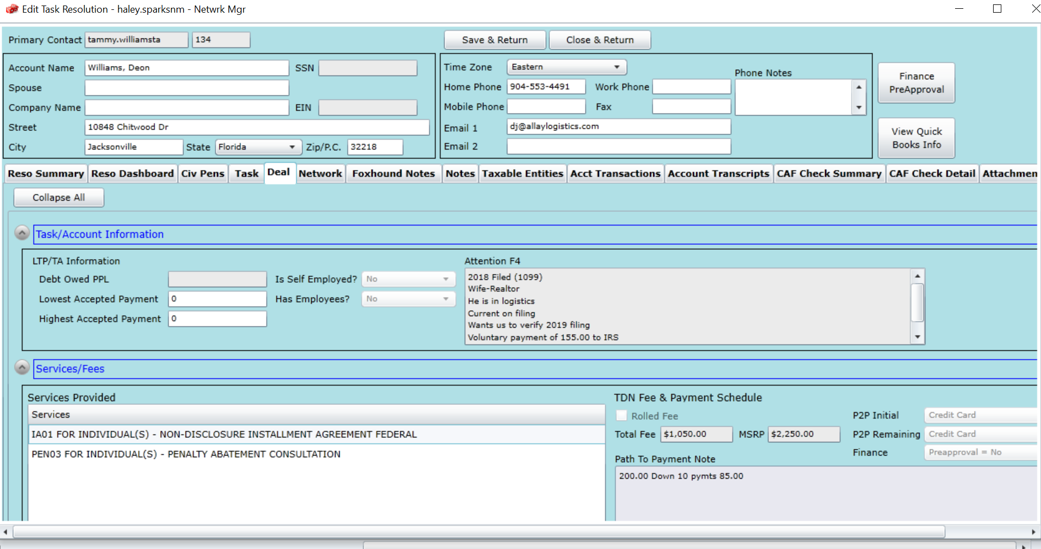

* + F4 Notes: The Resolution Consultant enters in notes on the client’s tax situation, their goals and any other important information. This is one of the most important areas to look at when reviewing the case
  + Services Provided: contracted services
  + Pitch Notes: These are additional notes from the Resolution Consultant broken down in the categories below:
    - All communication with or from the IRS: Has the client reached out the IRS on their own or received any notices?
    - Installment Agreement History: Is the client currently in an Installment Agreement or do they have a history of defaulting agreements?
    - Cause of debt: Why does the client owe?
    - Compliance: Is the client up to date on filing their returns?
    - Has talked to: Did the client speak or work with any other companies?
    - Financial Situation: Are they a W-2 or 1099 employee? Are the in a hardship?
    - Rock: Why the client reached out to us.
    - Gem: What the client’s ultimate goal is.

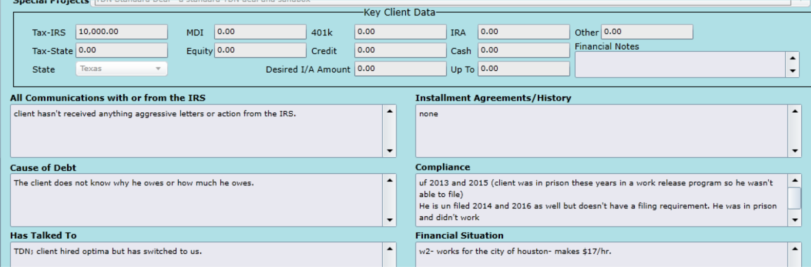



* Foxhound Notes

This is a full history of the case. Anything that has been done on a case once it gets to servicing will be logged here.

* + When reviewing for a Welcome Call you look through this section to see what documents the Case Coordinators have already sent to the client in the Welcome Email and if this is a client who worked with us previously what agreement was set up.
  + If reviewing the notes for a transfer case, you are looking through to see what has already been done and what needs to be done next.
* Attachments
  + Any documents received prior to the case moving up to servicing will be attached here.
    - Service Agreement
    - Power of Attorney & Tax Authorization Forms (2848 & 8821)
    - Personal Debt Sheet
  + Do we already have a Power of Attorney and Tax Authorization form?
    - If not, it must be requested from the client.
  + Do we have a Personal Debt sheet?
    - This gives us a breakdown of the client’s balances and other useful information

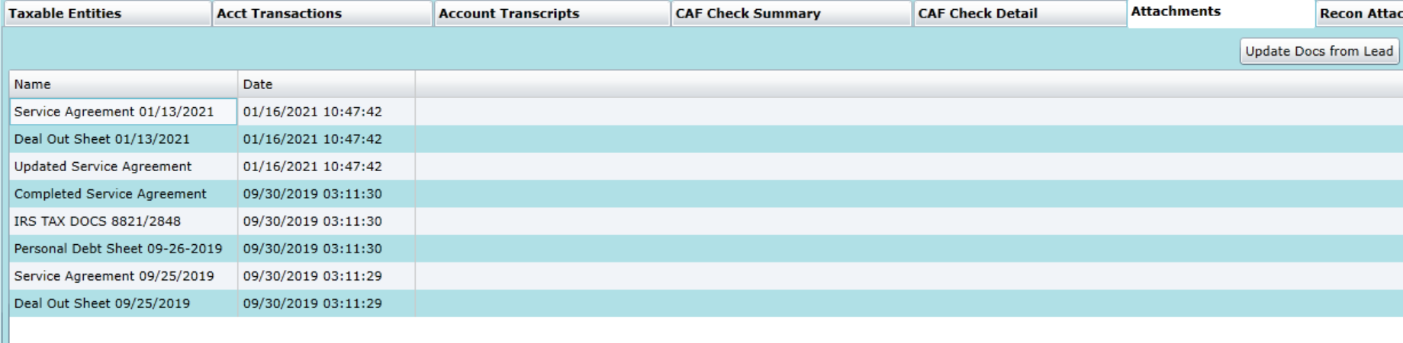

* I-drive: Every client has a file in the I-drive to store and organize documents
  + Misc folder: Should have Unsigned or Processed Power of Attorney Forms/Tax Authorization Forms.
  + Review to see what we have and what we may need.

**Before you make your call stop and evaluate!**

* Do you have an understanding of what the services are and what the client is expecting?
* What documents, if any, do you need from the client?
* What are the next steps?