**Weekly Webinar – Week #6 – 2016**

**Housekeeping Items**

1. Affiliate Partner Ranking Report going out late
2. Hold times for ACS have decreased
3. Manager Approval times for PPIA/CNC have decreased to 24-72 hours
4. New Case Assignments – Hold until further notice.
5. VERY IMPORTANT – Please do not provide clients with services that we are not contracted to perform. If we are not contracted to perform a service that needs to be done – Please submit a re-contracting request by using the Re-Contracting email template located in your Affiliate Partner Packet
6. New Tax Preparation Service Description –

**OLD VERBIAGE:**

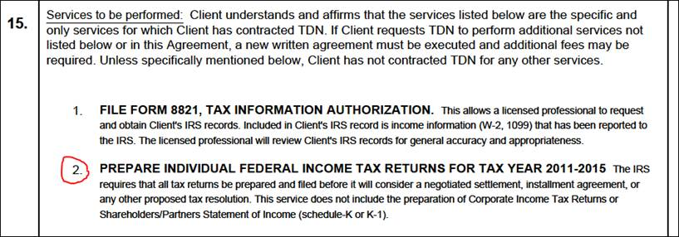

**NEW VERBIAGE:**

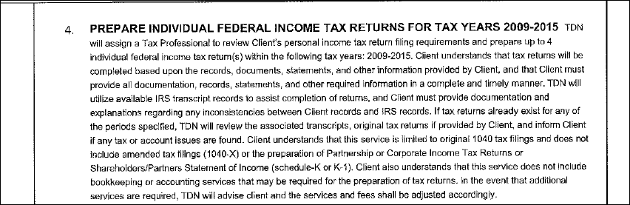

**Training**

**Tax Liens**

Tax liens are common amongst our clients, but often the lien(s) are not issued until after the resolution is put into place. So the first part of this is to cover when a tax lien will be issued, and then the next part deals with what/how to communicate information about a lien(s) to the client.

* Anytime, at basically any debt amount, that we put a client into CNC or a PPIA, the IRS will absolutely issue a Notice of Federal Tax Lien.
* If the debt is less than $25,000, and the client agrees to a Streamline Installment Agreement – the IRS will not issue a tax lien. In this case, the client does not need to set the payments up on a direct debit to avoid the lien (no 433D required).
* If the debt is between $25,001 and $50,000, and the client agrees to a Fresh Start Streamline Agreement set up as a direct debit, then the IRS will not issue a tax lien (433D required to avoid the lien). If the client refuses to set the payment up on a direct debit, then the IRS will issue the tax lien.
* Any debt that exceeds $50,000, and we put that client into either a full-pay installment agreement or a PPIA, the IRS is going to issue a Notice of Federal Tax Lien.

Question: Why does the IRS issue Notices of Federal Tax Lien?

Answer: To protect their interest in the debt.

Sometimes, we need to communicate with the client very early on about the possibility of the IRS issuing a lien, and sometimes, we may not need to have that conversation until the very end of the case.

**Scenario 1** – Let’s say that we are working with a client with a $55,000 debt. We know from the “Deal” notes that the client’s ability to pay is $500 to $700/month. We should immediately talk to this client about how to avoid the tax lien. Client can pay the “assessed” debt amount down to $50,000 by making voluntary payments, and then we can put into place a Fresh Start Streamline Agreement as a direct debit. Does it matter that we are contracted for an Asset Protection Plan? NO, it does not matter. Why? Because we make the client aware of all their options, and the pros/cons of each option. We then let the client make an informed decision about how they want to proceed. Do we need to recontract for the lessor service? NO. What if the client states in the “Deal” notes that their ability to pay is only $100 to $200/month? We should still have this conversation with the client, and at the very least give them the option to avoid the lien. Sometimes clients will give up their cable service, or reduce their expenses in some other way just to avoid the lien. This is true anytime that a Streamline Agreement is within the realm of possibility.

**Scenario 2** – Let’s say we are working with a client and they have a $250,000 debt, and all indications from the “Deal” notes is that the client will be CNC. Do we need to cover the fact that a tax lien has or will be issued right away? No – not really. More importantly, in a case like this, we need to make the client aware that an RO is going to be assigned to their case, and talk about the process to guard against enforce collections. At the end, when we know the client will be CNC, we can tell the client that within 30-90 days of the IRS coding their accounts CNC, the IRS will issue Notices of Federal Tax Lien. Client may receive those notices after we close the case. Therefore it is very important that you clearly discuss the tax lien(s), and let the client know that the notice will come to them Certified Mail. Tell them to not be alarmed by the notice(s) because it is just the IRS following their Standard Operating Procedures. The IRS issues the notices to protect their interest in the debt. IRS is not going to seize their home or cars. However, if the client sells real property, or wins the lottery, then the IRS is assured that the debt will be paid. However, once the debts expire, then the lien(s) expire, the penalties expire, the interest expires, everything expires and they are no longer responsible for the debt. What if the client wants a copy of the lien? Direct the client to visit the Clerk of the Court in their county, and request a copy of the lien from the Clerk of the Court. On the face of the tax lien, the CSED is in column E. Also note the box stating, “IMPORTANT RELEASE INFORMATION”.

[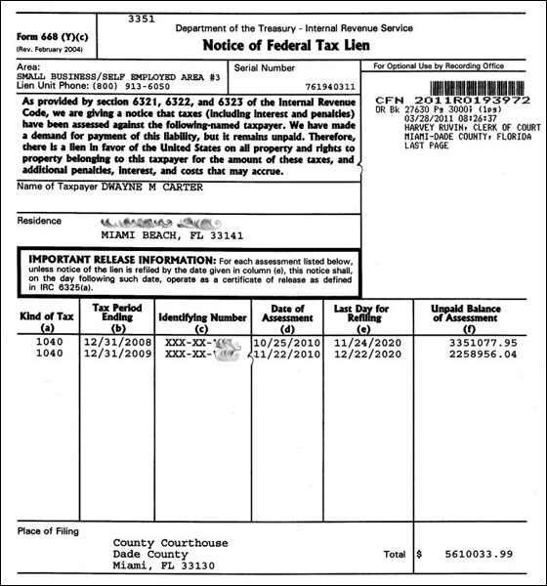](http://www.google.com/url?sa=i&rct=j&q=&esrc=s&source=images&cd=&cad=rja&uact=8&ved=0ahUKEwi5l8C48_LKAhXK5SYKHfyCDHoQjRwIBw&url=http%3A%2F%2Fwww.pappastax.com%2Ffederal-irs-tax-lien%2F&psig=AFQjCNFLbGjSJp2uJkAONMTgo8hPKM2fXg&ust=1455389611233398)

In summary, the important take away of all this is that anytime a tax lien could be issued to a client, we need to discuss three things:

1. Tax Lien(s) are issued when….
2. You have the ability to avoid a tax lien being issued by….
3. If tax lien is going to be issued, it will affect you in this way….

**Tax Cheat of the Week**

**Restaurant Chain Accountant Sentenced For Tax Fraud Scheme**

On Aug. 6, 2015, in Philadelphia, Pennsylvania, William J. Frio, of Springfield Township, was sentenced to 60 months in prison, four years of supervised release and ordered to pay $1.7 million in restitution. Frio pleaded guilty on Jan. 26, 2015, to conspiracy to commit tax evasion, filing false tax returns, loan fraud and aggravated structuring of financial transactions. Frio was an accountant and income tax preparer who provided services to the Nifty Fifty’s organization dating back to 1986. Frio and five others, including the restaurant chain’s owners and managers, participated in a long-running scheme to avoid paying millions of dollars in personal and employment taxes. The scheme defrauded the IRS by failing to properly account for more than $15 million in gross receipts. Frio and the owners and principals of Nifty Fifty’s conspired in a scheme to use skimmed cash to pay themselves and people and businesses who supplied goods and services to the Nifty Fifty’s restaurants. In 2008, Frio submitted a false loan application and other documents to a bank, for a $417,000 mortgage for his personal residence. Between January 2009 and November 2009, Frio knowingly structured transactions with the bank, totaling more than $2.6 million, as part of a pattern of illegal activity involving transactions of more than $100,000 in a 12-month period. Frio used his position as the Nifty Fifty’s accountant to embezzle millions of dollars that belonged to the organization.

[](http://www.google.com/url?sa=i&rct=j&q=&esrc=s&source=images&cd=&cad=rja&uact=8&ved=0ahUKEwiExf2Z8PLKAhWG6iYKHRJ4DW0QjRwIBw&url=http%3A%2F%2Fniftyfiftys.com%2Femployment.html&psig=AFQjCNE17Tv6tZLSZgRrgPZM0rSCCBd2sg&ust=1455388860910744)