**Voicemail Setup**

How to log in and record message:

* Go to service.ringcentral.com, this will bring you to a login portal.
  + Phone number is +19046856720#(your ext)
  + Password is RingCentral123



* + You’ll have to put in the same info a second time.

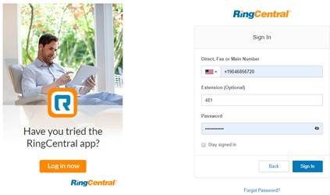

* + Sign in
* Go to Settings then Messages & Edit

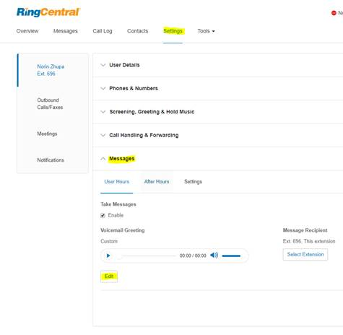

* Change the drop down to Custom
  + This will give you the option for RingCentral to call you for the new VM recording.  Enter the number for your direct line and you will immediately receive a call to record.

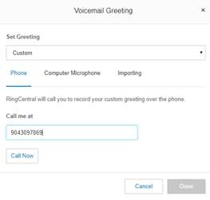

* Press 1 and record the greeting.  Follow the instructions.