**BBB (Better Business Bureau) and You**

**Prompting the Client for a POSITIVE BBB Review**

The purpose of this Webinar is to introduce a very important initiative under-foot at TDN – reaching and maintaining 1,000 positive reviews on the BBB website.

There is an initiative a-foot to reach 1,000 positive BBB reviews. So, when closing a case, if you know that the client is happy with our services, ask them to email in a positive BBB review. The reviews are confidential, meaning that the BBB will not publish the client’s name, nor will the BBB publish your name. Make certain that [the](Karle%20with%20Cigar.jpg) client does mention your name in the review so that we can give you credit for the positive review.

*Positive BBB Reviews*

To solicit a positive review, simply address the topic verbally with your clients. If you are SURE they are happy and have a positive disposition regarding TDN, then there should be no reason not to introduce the topic at the end of your closing call.

**Review Solicitation Script:**

*Ms. ________, it was a pleasure for me to help you. Would you mind leaving a positive review on our BBB website?*

*We think the information would be helpful for people who are considering seeking help for similar tax situations, and we are running a contest where I earn a raffle ticket for every positive review I receive – so it would help me out as well.*

*It only takes a few seconds. I’ll send you the email now and walk you through it if you have a quick minute.*

Did you call the client at home? Do they currently have access to email? Can they do it now?

*I’m sending the link now. Can you tell me when you get it?*

*If you open the email, do you see the hyperlink? It’s the underlined writing toward the bottom of the email.*

*Can you click on it? Some clients have trouble with it and I want to make sure it works.*

*Your comments don’t have to be long, and you can edit it later if you want to add more.*

If the client is UNABLE to do it now:

*Ok. I’m sending you the link now, so it will be in your email. When you go into the email, click on the enclosed link and it will bring you straight to our BBB webpage. You can click “Submit a Customer Review” on the right hand side of the page. I’ll include an image along with the email.*

Make SURE they know they need to click the confirmation email.

*After you complete the review, you will receive an email from the BBB asking you to confirm your post. Please make sure you click on the link and confirm your review. If you don’t click the link to confirm, your review will not post.*

Ask if they have any questions and make sure they know to call us if they have problems.

**Review Solicitation Email:**

**Send out the link in a separate email to the client – NOT with the closing letter. The link is below along with a template email. Put POSITIVE REVIEW FOR ME in the subject line of the email.**

Mr. ___________,

Here is the link to the BBB website we discussed on the phone. Feel free to leave a comment regarding our quality service. Your comments will help others who may be hesitant or unsure about using our services.

<http://www.bbb.org/north-east-florida/Business-Reviews/taxes-consultants-and-representatives/tax-defense-network-inc-in-jacksonville-fl-184747163/Customer-Reviews>

Here is a screenshot showing where to go to submit a positive customer review.

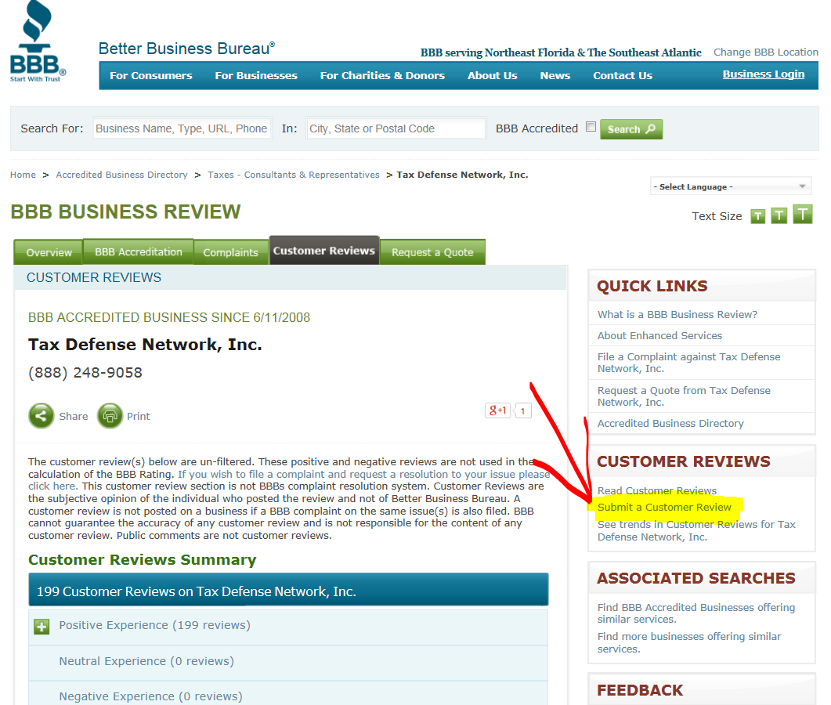

It was a pleasure working with you, and I wish you and yours the best.

Thank you,

We strive really hard to maintain an A+ rating at the BBB. The rating itself draws a great many clients to TDN, and we are very proud of the fact that we provide every client FIRE and ICE. Maintaining our A+ rating is achieved by limiting the number of BBB complaints, and also by achieving a high number of positive BBB reviews. One-thousand (1,000) reviews is the maximum number that the site will allow, and reviews older than 12 months are removed from the site. So we need your help to achieve 1,000 positive reviews, and to maintain 1,000 positive reviews.