Go to your portal at https://www.securetaxportal.com/dcTaxPortal  **1st time users, click “Sign Up” and log in, use your email & last 4 of your SSN | 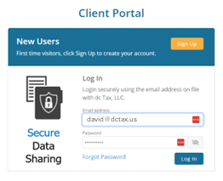
Create a password.  You’ll get an email with a 6-digit code. Copy that code & paste into the Security Code field.  Continue to Portal | 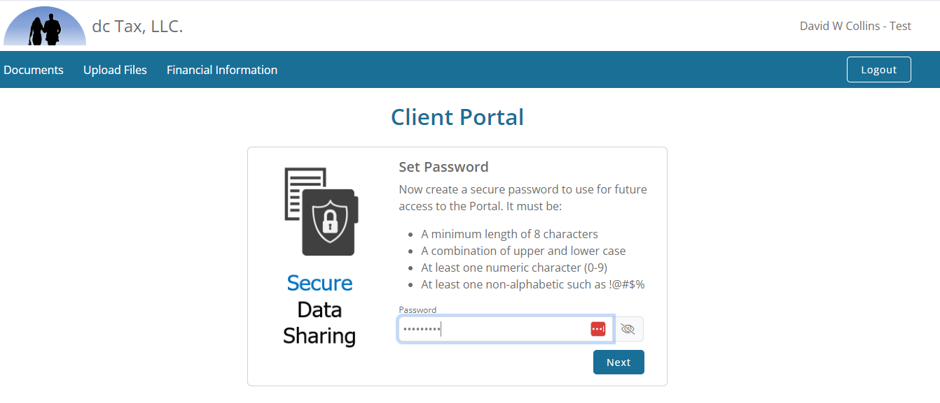  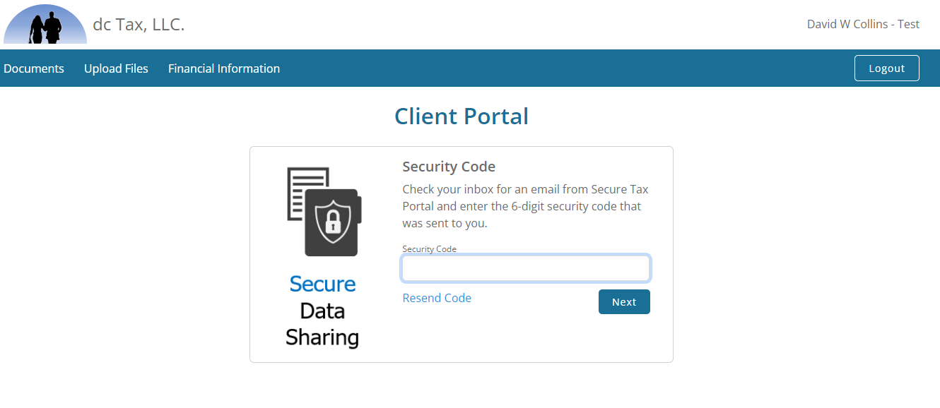  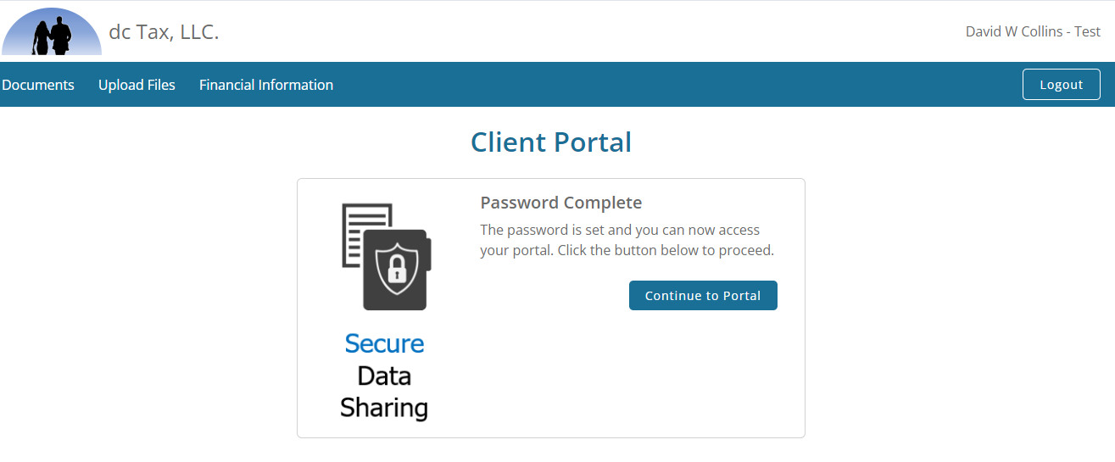
From here, you can download documents from us, upload documents to us, and if needed, enter/update financial information. | 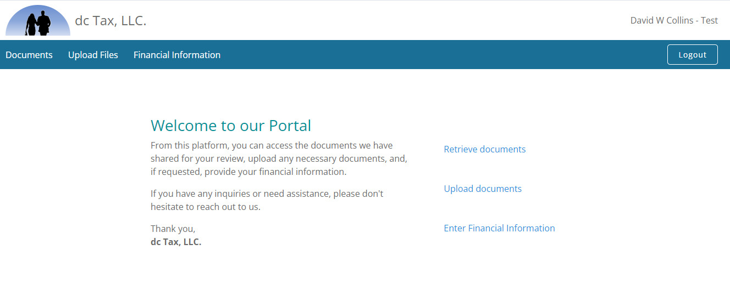
To upload documents, either drag the file to this window or, click “Choose Files” and select the files you want to upload.  When finished loading all the files you want, click “Upload”. | 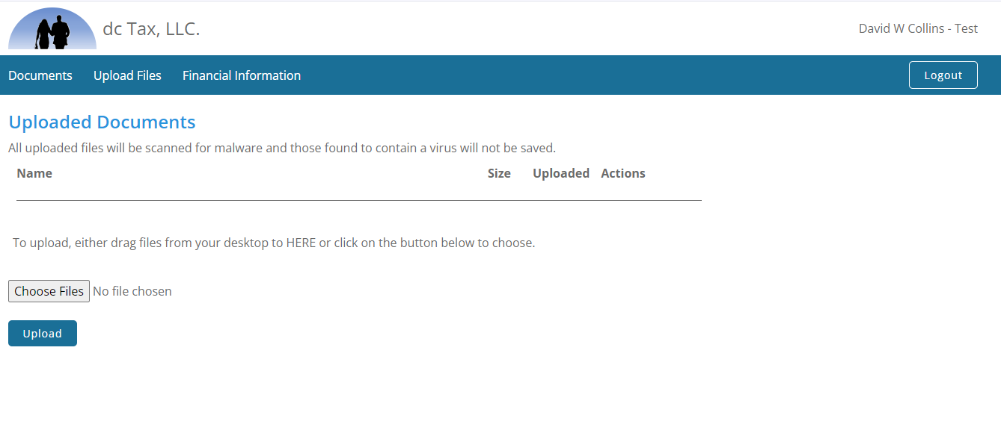
If financial information is needed, you’ll see the “Financial Information” Link which brings you here. Click on any of the tabs across the top – Personal & Emp., Other Financial, Bank & Investment, etc. | 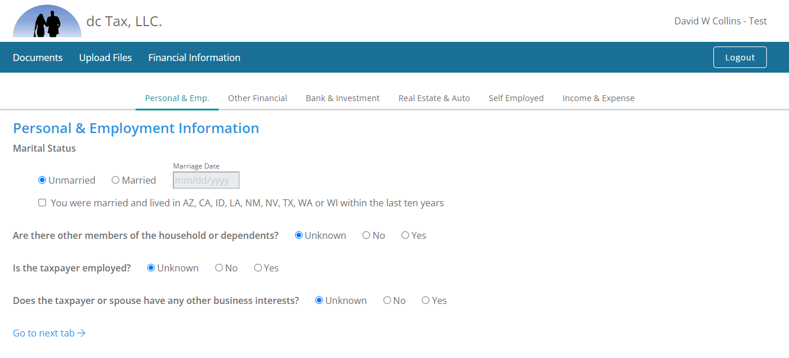
When you are finished, simply click, the “Logout” button.

