# How to make a payment at IRS.gov website

1. **Go to** [**https://www.irs.gov/payments/direct-pay**](https://www.irs.gov/payments/direct-pay)

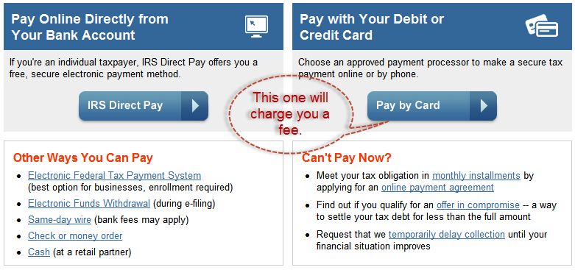

1. **Select “IRS Direct Pay” on the left.**

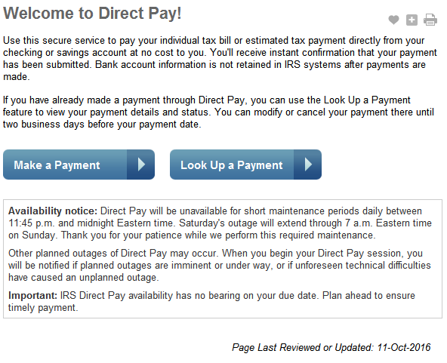

1. **Select “Make a Payment”**
   1. ***You can choose multiple reasons for the payment***

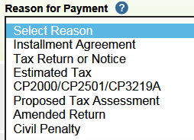

* 1. ***And what to apply the payment to:***

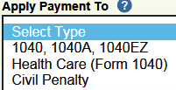

* 1. ***But for this, we will apply an estimated tax payment to our 1040 return.***

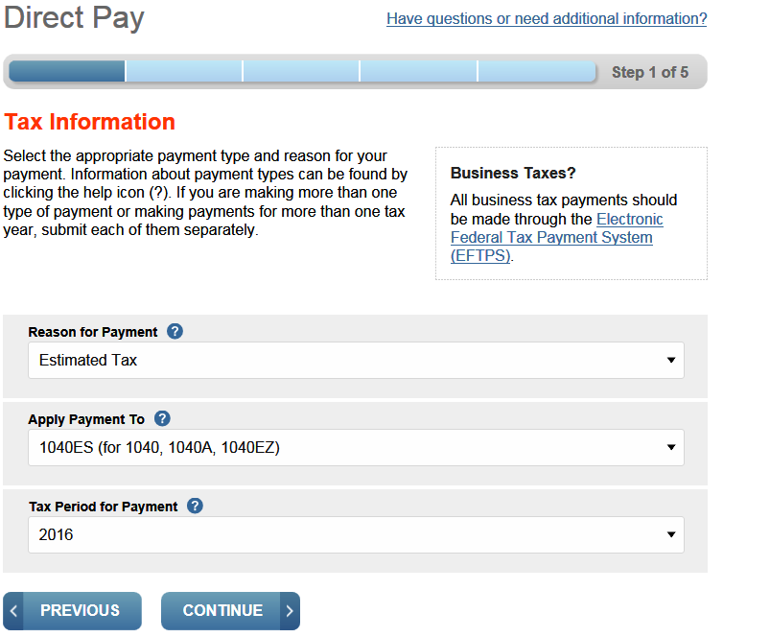

1. **This is “Step 2” on the web page. Fill in your personal information**.
   1. *The “Tax Year for Verification” is just the tax year that you want to use information from for the rest of the form so they can make sure the payment is applied to the correct person.*

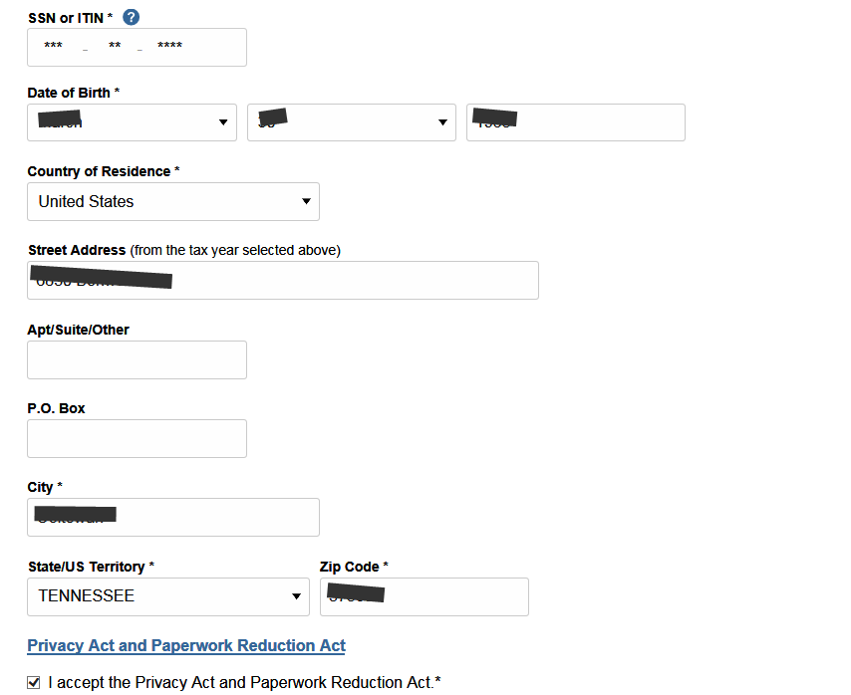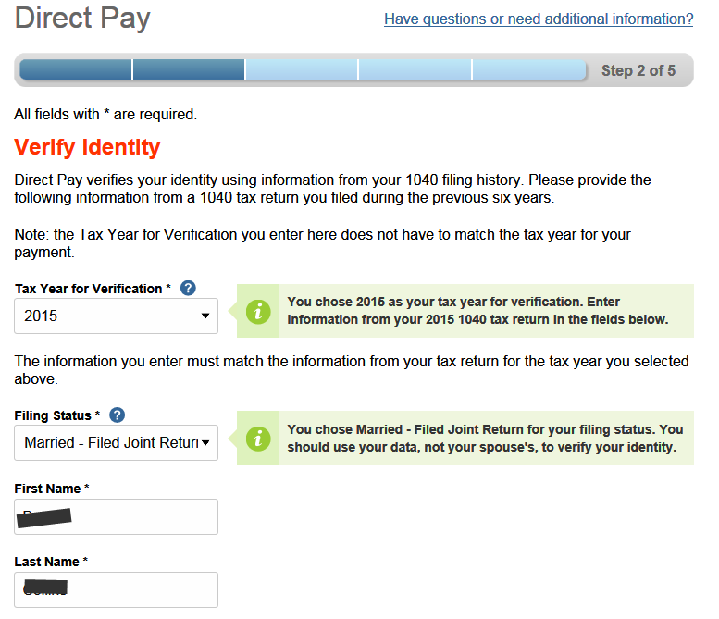

1. 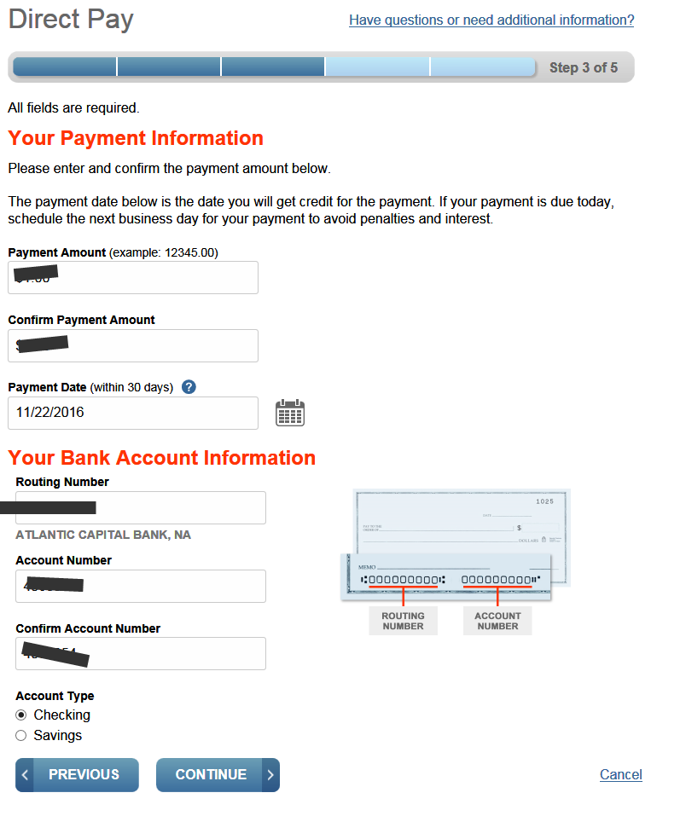**Step 3 of the web page process: payment information**
2. 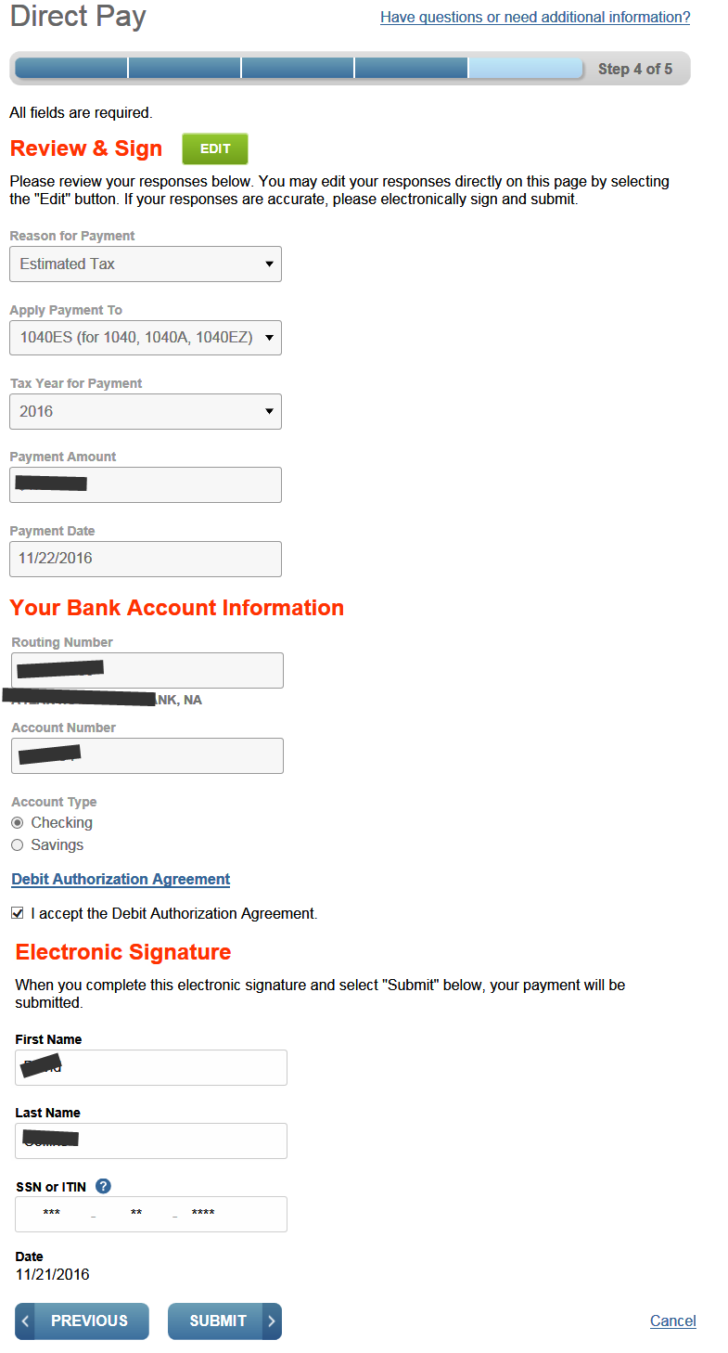**Verify all of your information and submit**
3. **Finally, the payment is done & you get a confirmation number**

