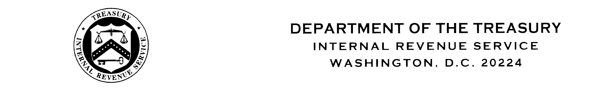 June 5, 2013

MEMORANDUM FOR: David Collins

FROM: IRS Employee Suggestion Program

SUBJECT: Employee Suggestion Number, 50-20-13-024

Thank you for your interest in improving the IRS and for participating in the Employee Suggestion Program.

Your suggestion is still being evaluated. You will be informed once the evaluation process is complete, and should receive a response within 20 days from the date of this letter.

For questions regarding the status of your suggestion, please contact Valerie Hunter at (512) 339-5317.

cc: Headquarters ESP Program Manager

