Open Outlook and, holding down the “Ctrl” key, click “F11”. (opens the VBA code) | 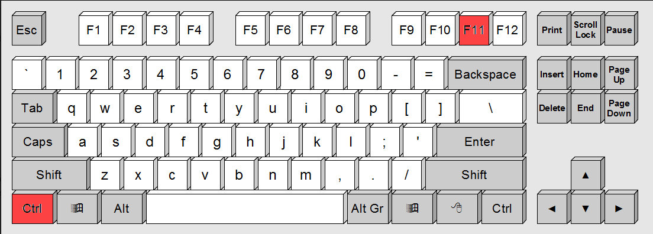
You will see something similar to the following screen:  On the left, under “Project1 (VbaProject.OTM)” you’ll see “This OutlookSession”. If it’s not there, look for and click the “+” sign beside Microsoft Outlook Objects . | 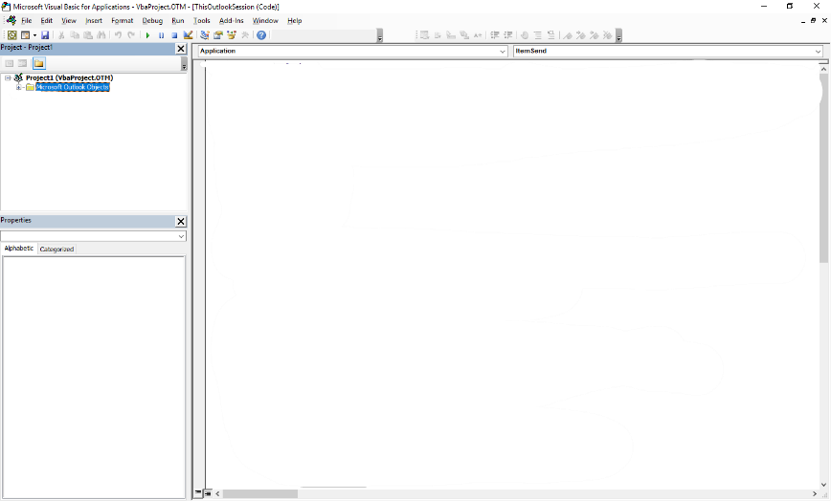
Open the file “Session.txt”. Click “Ctrl” & “A” (selects all the text) and then “Ctrl” & “C” (copies the selected text ) | 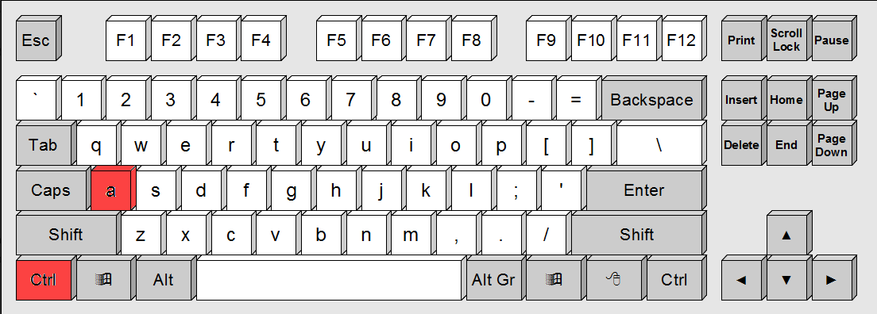  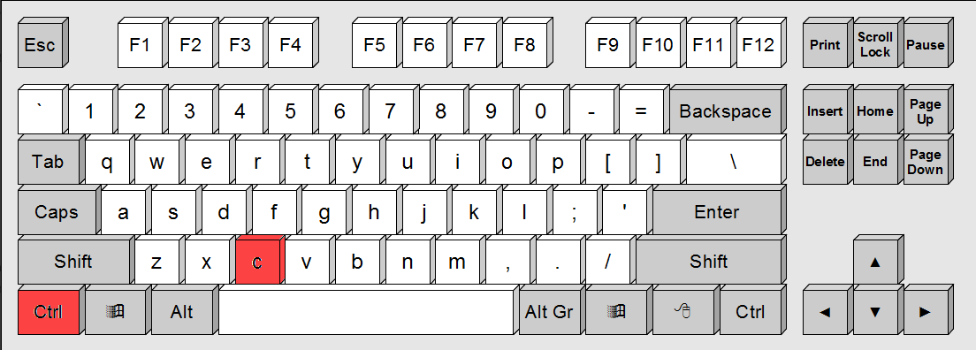
Then, double click “ThisOutlookSession”  That will open a blank window to the right of this window. | 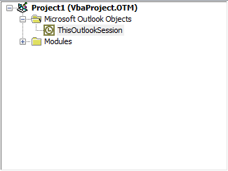
Click inside that window and click “Ctrl” & “V” (pastes the selected text ) | 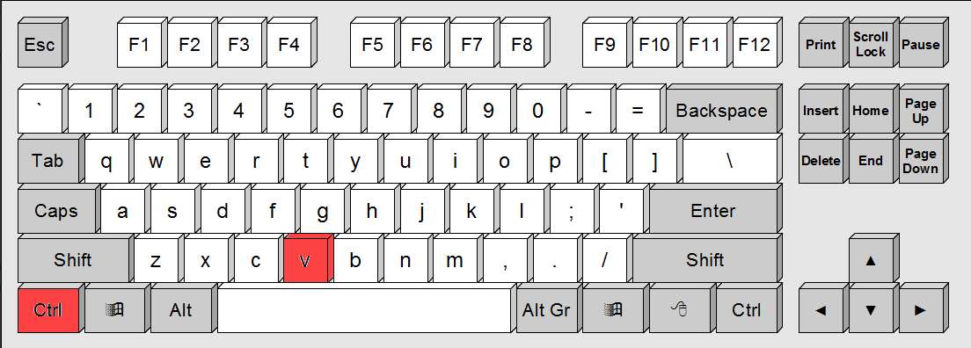
Close the file “Session.txt”  Now, right click “ThisOutlookSession” and select “Insert” and then “Module”.  Again, you’ll get a blank window to the right. | 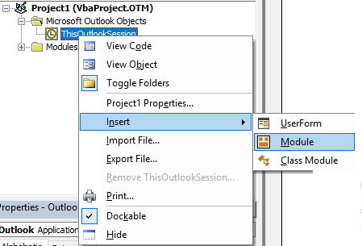

Open the text file “ZipAttach.txt”.

Click “Ctrl” & “A” (selects all the text) and then “Ctrl” & “C” (copies the selected text )

Go back to Outlook and click in the blank window you just created.  Click inside that window and click “Ctrl” & “V” click “Ctrl” & “V” (pastes the selected text )  Click “Ctrl” & “S” click “Ctrl” & “V” (saves the VBA file)  Click “Alt” & “Q” (quits the VBA editor) | 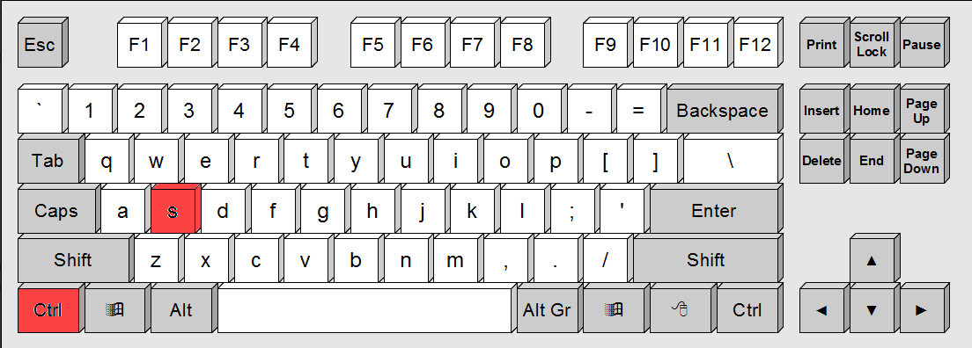  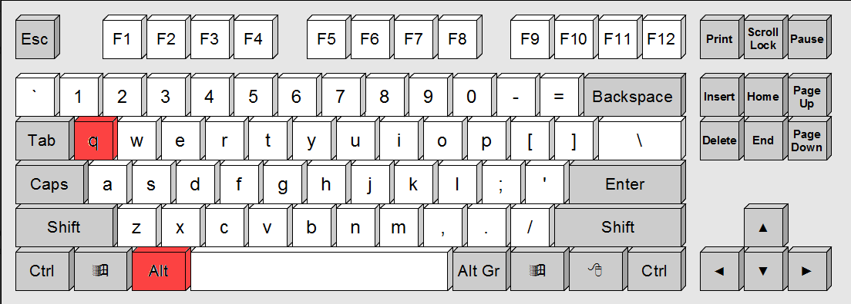

Close the file “ZipAttach.txt”.

You’re done.

