Making estimated tax payments online from “irs.gov”.

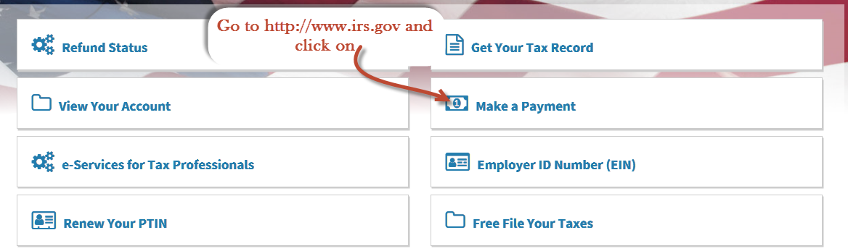

**2.**

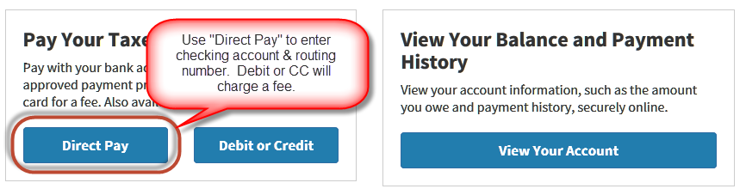

**3.**

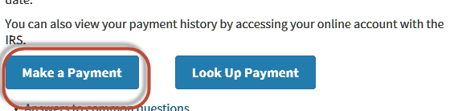

**4.**

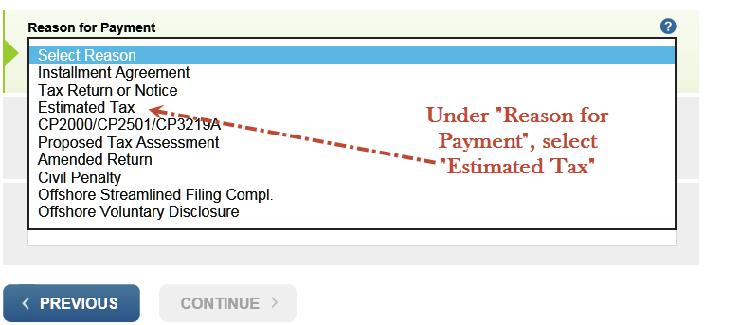

**5.**

