  It’s intimidating  Nobody wants to deal with the government, much less the IRS. Before you do anything in the “heat of the moment”:  Stop. Do not answer any questions.  Politely tell the person you have a representative.  Give them our phone number.  How we can help:  - We deal directly with the IRS on your behalf.  - Ensure any determinations of your ability to pay are accurate and do not hurt you, your family, or your business.  - Installment agreements  - IRS Appeals  - Offers in Compromise  - Innocent Spouse applications  - Trust Fund Recovery Penalty  - Mitigating federal tax liens.  - Abatement of penalties & interest  - Requests to stop levies or appeal levy determinations.  - Complete & file quarterly 941 returns & annual 940 returns.  - . . . and much more . . . |  |  | Who We Are  We are former Revenue Officers for the IRS. As such, we are keenly aware of how the collection side of the IRS works.  If you have been contacted by the Internal Revenue Service, not sure what to do or where to start, or if you simply want someone to review your tax situation, see how we can help.  There is no cost for initial consultation and all costs are clearly detailed with no hidden fees, add-ons or additional costs.  Contact Us  Phone: (423) 482-9737 (4TA-XREP)  Email: david@dctaxllc.com  Web: http://www.dctaxllc.com   dc Tax, LLC PO Box Ooltewah, TN 37363 |  |  | 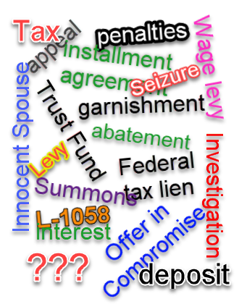  dc Tax, LLC  tax representation for us common folk.

  Have you seen or heard that ad?  The one that talks about how tough someone is with the IRS…  The truth is, if you are contacted by the IRS concerning not filing or having a balance due, there is nothing anyone can do to force the situation, no magic filing to eliminate your debt or guarantee a particular outcome.  We will never tell you that we can eliminate your debt, get federal tax liens released or even settle for pennies on the dollar.  Of course, we will try to do all that, but the truth is that it rarely happens. What we can tell you is that we will do everything we can to make sure you are treated fair and equitably. |  |  | Revenue Officers are generally good people.  The system is the problem. The organization itself is, to a certain degree, numbers driven, political and unbelievably overburdened.  The person contacting you is just doing their job and their job is to look out for the government’s best interest, not yours.  We look out for your best interest.  “their job is to look out for the government’s best interest, not yours”  Do you know your options?  The person contacting you simply needs to close your case as soon as possible. Ideally, that means you give them all the returns and a check for the balance due plus penalties and interest. And, if that’s not possible, how much can you pay right now?  The truth is, you have more options than you realize. |  |  | Typical costs  Typically, you can expect to pay powers of attorney between $150 - $400 per hour. Some may offer a flat fee for simple, routine work.  Most representatives will not even give you a quote until you call them. These are the fees we have found online from real companies.  Installment Agreements $500 - $1,500  Offers in Compromise $2,000 – $5,000  Penalty abatements $500 – $2,500  File an appeal $2,000 – $7,500  The problem with these is that there is more to every case than the chargeable service. You will usually end up paying the hourly fee IN ADDITION to the chargeable service.  Here’s how we work.  In our initial consultation we will look at your tax history and identify all the issues. We will then lay out a plan to remedy the issues and get you back in good standing. Technically, there is nothing we do that you can’t do yourself. At the end of the visit, you will know everything that needs to be done. You can choose to do it yourself or hire us to do it for you.  During your case work, if anything changes (and it sometimes does), we’ll let you know in advance if there are any additional costs involved.  You will never be surprised by your bill.  Lastly, we never charge you up front (retainers). We will only bill you for work we actually do.

